MyoGrind: A Wearable EMG Device for Bruxism Management

**What is the project?**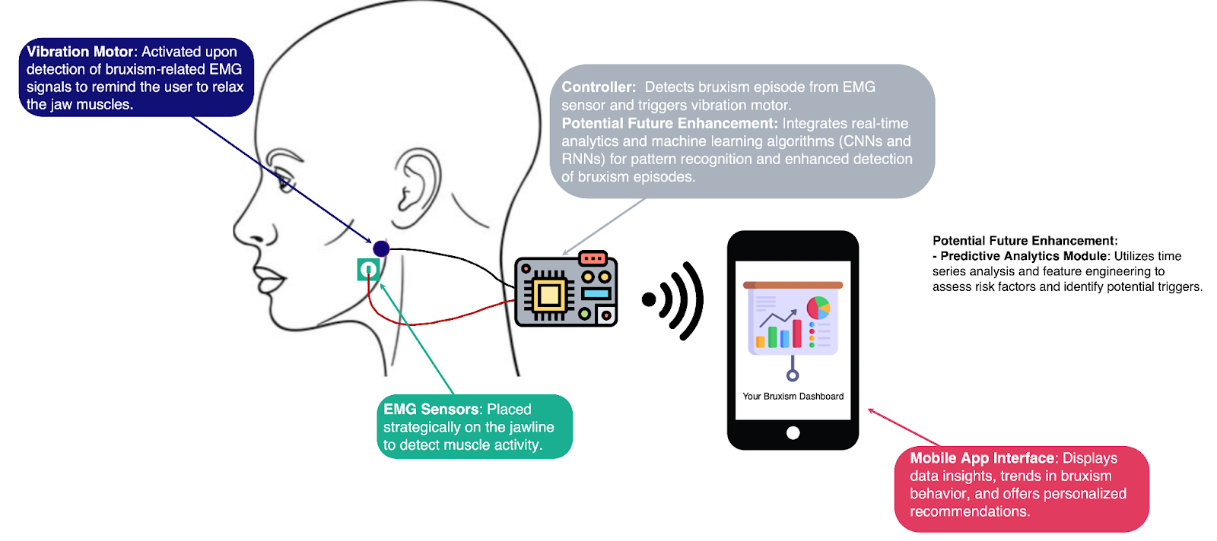

We propose a wearable EMG device that uses real-time data to detect bruxism episodes accurately, offering personalized insights and enabling proactive management to enhance oral health.

* EMG electrodes placed on masseter muscles.
* Vibration motor to provide gentle vibrations to alert users and relax muscles.
* Arduino Uno with MyoWare shields to collect/stream conditioned EMG signals.
* App interface to receive analytics and control vibration motors.

**Who does it serve?**

1. Patients diagnosed with Bruxism:
   * Individuals experiencing symptoms like teeth grinding and jaw clenching.
2. Preventative users:
   * Those susceptible to bruxism due to stress, sleep disturbances, or joint disorders can benefit from the preventive measures provided by this tool.
3. Dental professionals:
   * Dentists, orthodontists, and dental hygienists interested in integrating advanced technology into their practices to improve patient care outcomes.
4. Research Institutions and Clinics:
   * Researchers studying bruxism causes and treatments. The device can be a tool for data collection and analysis in clinical studies.

**Our hypothesis:**

Bruxism, or teeth grinding is a common issue faced by some people. We hypothesize a bruxism management device that can effectively detect bruxism in real-time using EMG sensors. This detection prompts immediate feedback through gentle vibrations to the cheek to relax the jaw for both night and day uses. Continuous use aims to increase user awareness and control over their grinding habits. We hope this will potentially reduce or stop bruxism. The accompanying app we will develop will provide advanced data insights, helping users monitor and manage their condition proactively, thereby improving oral health and quality of life by alleviating discomfort and preventing dental damage.

**Value proposition:**

* Our product provides unique value by being one of the only smart devices to detect teeth grinding episodes immediately and provide gentle vibrations to alert and help users understand and manage their bruxism more effectively.
* Added benefits are included in our device being easy to use and wear so users can receive benefits during the day and night, thereby enhancing daily comfort and long-term dental health

**We need your help…**

1. Technical feasibility: We plan to incorporate machine learning to improve detecting bruxism episodes. Are there any perceived problems for incorporating machine learning into this device?
2. User control: What features do you think are important for the users to control rather than being hard-coded or developer-controlled?
3. Design and usability: Do you have ideas for making the design user-friendly? Where would you keep the MCUs (behind-the-ear vs. headband)?
4. Compliance and Safety: Are there any potential regulatory hurdles you foresee? Do you have suggestions for user safety or data security?
5. Impact and Value Proposition: How might it be improved to appeal more strongly to potential users?

**We are looking for potential consumers to understand their needs and improve our product design! So please let us know if you know anyone who would be willing to talk with us!**